Kaizen App – Process & Data Flows
Oct 27, 2026 · @BG

1. System context
Kaizen App is the only place Lean data is entered; outside systems only provide login and notifications, receive a monthly reward file, and (phase 2) send camera frames. There is no ERP write-back.
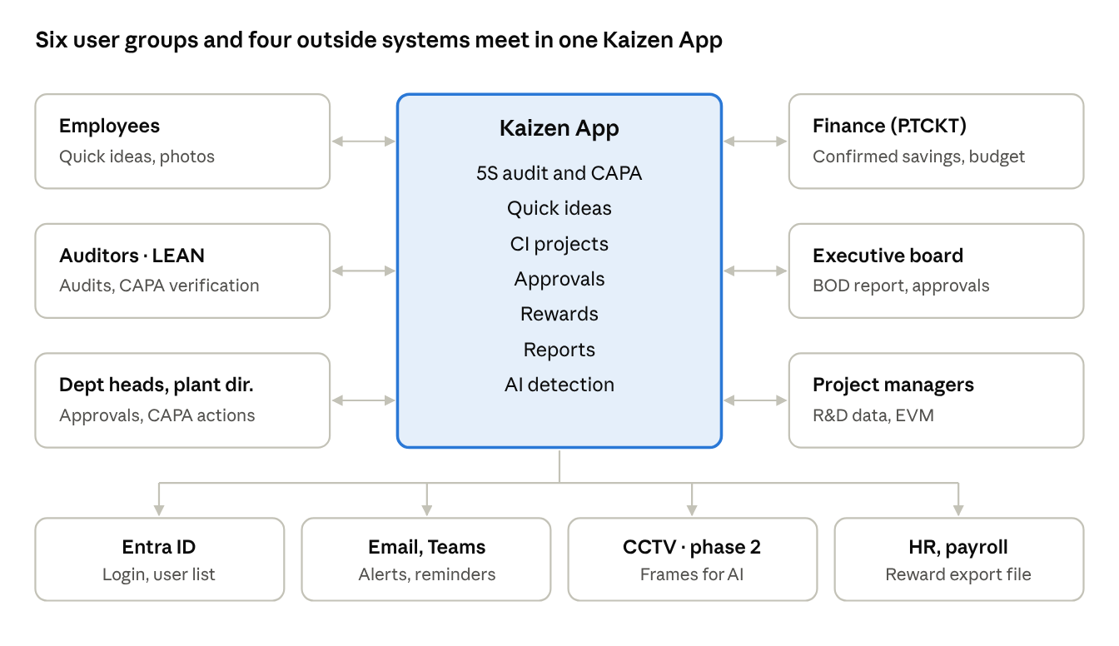
system context · 6 user groups, 4 outside systems
Outside system | Direction | Data | Frequency
Microsoft Entra ID | In | Login token, name, email, department | Every login; user list nightly
Email, Microsoft Teams | Out | Approval requests, SLA reminders, overdue CAPA, report ready | On event and daily 07:00
HR / payroll | Out | Approved reward lines per person (T1–T4) as an Excel/CSV file | Monthly, after month close
CCTV (phase 2) | In | One frame per camera every 5 minutes to the AI service | Continuous

2. 5S audit and CAPA
Every score of 2 or lower becomes one CAPA automatically, and a CAPA closes only after LEAN verifies the after photo; nothing in this flow is typed twice.
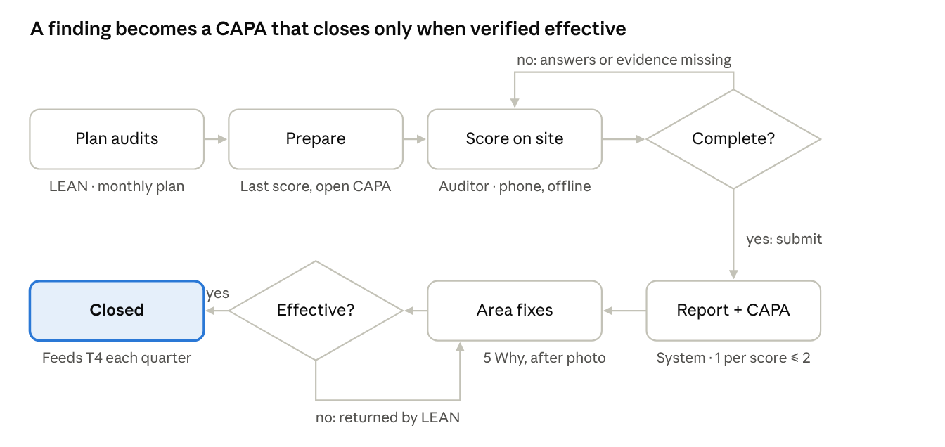
5S audit and CAPA · 7 steps, 2 decisions
Step | Actor | Reads | Writes
Plan audits | LEAN | Areas, auditors | audit_plan (area × month × lead auditor)
Prepare | Lead auditor | Last audit of the area, open CAPA, recent ideas | —
Score on site | Auditor, phone (offline) | Question set version, area type | audit (draft), audit_answer per question with score, finding, zone, photo; optional ai_scan
Complete? | System | Answers | Blocks submit if an applicable question is empty or a score ≤ 2 has no finding
Report + CAPA | System | Answers | audit (submitted, % per S, total, conclusion, maturity); capa per score ≤ 2, due date by class, before photo = answer photo
Area fixes | Area owner | CAPA | capa 5 Why, action, after photo, done date
Effective? | LEAN | CAPA, after photo | capa verified (closed) or returned (done date cleared)
Overdue status is set by the nightly job, not by users. A quarter close reads all submitted audits to rank areas for T4 (section 6).

3. Quick idea to Kaizen
An employee goes from photo to approved idea in two steps; the level and T1 amount are computed from what was filled in, never typed.
- Submit (employee, phone): area, S category, problem, idea, before/after photos, benefits, self-implemented flag. Optional 5 Why lifts it to level 2; data before/after plus a standard (OPL, SOP, 5S standard) lifts it to level 3. System sets level and status Pending; if self-implemented with an after photo, status starts at Implemented.
- Approve (department head, SLA 2 days): status Approved, or rejected with a comment back to the author.
- Implement (author or department head): add the after photo if missing; status Implemented. A T1 reward line is created for (author, month) and capped at 1,000,000 VND per person per month.
- Transfer to Kaizen (department head or LEAN): system issues KZ-QI-YYYY-nnn; status Transferred.
- Optional branches
  - Level-3 implemented idea → plant director or LEAN marks it Kaizen of the month → T2 line 1,000,000 VND.
  - Idea too big for a quick fix → Upgrade to project opens the PDCA wizard prefilled (name, area, author as leader, problem) and links idea.project_id; flow continues in section 4.
Data written: quick_idea (+ photos in storage), approval_step for step 2, reward_line for T1/T2, audit_log for every status change. The 5S audit later reads ideas of the last 90 days per area (question S5.08) and before/after pairs (S1.06, S5.09).

4. CI project lifecycle
Nothing can be entered on a project until every approver in its chain has approved; after that, each phase ends at a tollgate with its own approvers, and money is released in two steps.
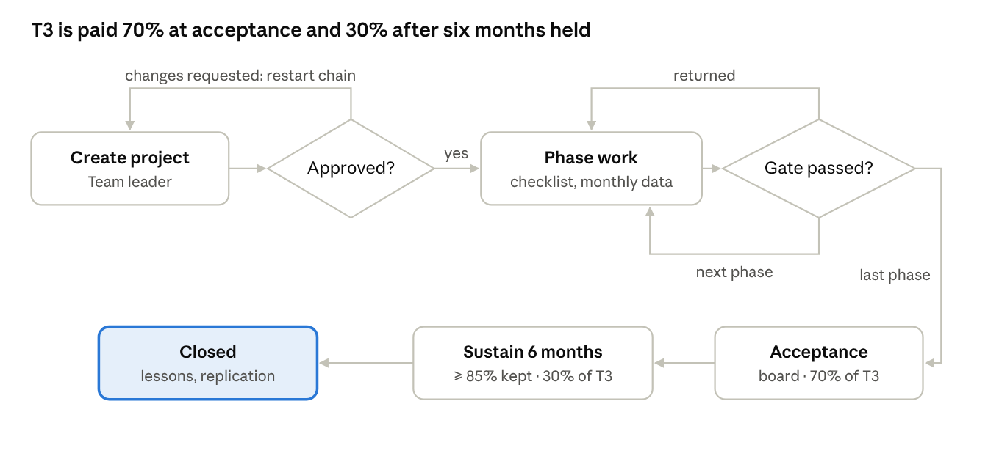
CI project lifecycle · approval, tollgates, acceptance, sustainment
- Create project (team leader): wizard data; the approval chain is chosen from method and investment (PRD 3.7) and stored on the project, so later rule changes do not alter it.
- Approved? Each approver in order approves or requests changes. Changes requested: status "Changes requested", the team edits and resubmits, and the chain restarts at the first approver.
- Phase work (team): tick the checklist of the current phase; enter monthly KPI, cost, hours; Finance confirms monthly hard saving.
- Gate passed? Submit is enabled when the checklist is complete. Approvers per phase (PRD 3.7). Returned: the phase stays open with the comment. Passed: tollgate_log row, next phase opens.
- Acceptance after the last phase: hard-saving projects fix S (Finance-confirmed); others get a score 0–100. A T3 reward line for 70% is created.
- Sustain 6 months: a reminder is created for acceptance date + 6 months. Finance or LEAN confirms ≥ 85% of the result held → the remaining 30% is created; not held → 30% is cancelled with a reason.
- Closed: lessons learned and replication (Yokoten) noted; project becomes read-only.

5. AI detection and model lifecycle
The model only suggests: a person confirms each detection before it becomes a CAPA, and every confirmation or correction is kept as training data for the next quarterly model.
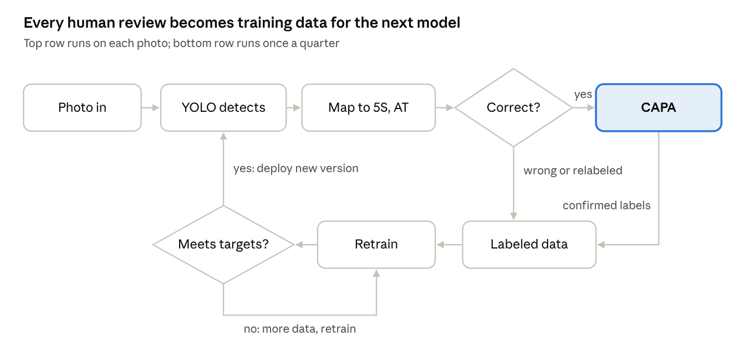
AI detection · per-photo loop and quarterly learning loop
Step | Where it runs | Data
Photo in | Phone camera, audit question photo, CCTV frame (phase 2) | Image compressed to ≤ 900 px; faces blurred before upload
YOLO detects | ONNX Runtime Web on the phone (MVP); GPU AI service for CCTV (phase 2) | Boxes [x, y, w, h] normalized 0–1, class id, confidence; NMS IoU 0.45; display threshold 35%
Map to 5S, AT | Backend, from ai_class master data | 5S question or safety code, severity, CAPA class
Correct? | Reviewer (department head, plant director, LEAN) | Per detection: correct, wrong, or relabeled to another class
CAPA | Backend | One CAPA per confirmed detection; before photo = image with boxes drawn
Labeled data | Backend export | Confirmed boxes in YOLO format plus corrections, linked to the model version that produced them
Retrain | Data science, quarterly | Ultralytics YOLO11n/s, 640 px; split by unit to avoid leakage
Meets targets? | Data science + LEAN | mAP@0.5 ≥ 0.70; recall ≥ 0.90 for high-severity safety classes; registered in ai_model_version before deploy
Precision in the app = detections confirmed with the same class ÷ all reviewed detections, per predicted class. Recall needs missed objects drawn by reviewers, so it is measured on the validation set, not in the app.

6. Rewards and monthly reporting
Rewards are never typed in: a scheduled job turns events into reward_line rows, people approve them, and Finance exports what is approved. Reports read only confirmed data.
Line | Trigger event | Calculated by | Approved by | Paid
T1 Quick idea | Idea reaches Implemented | Job on save; monthly cap per person applied at month close | Department head (with the idea) | Monthly
T2 Kaizen of the month | Level-3 idea marked | On save | Plant director or LEAN | Monthly
T2 CI Star | Fiscal year close | Year-end job (threshold to confirm: 20 or 30 points) | LEAN → Executive board | Yearly
T3 Project, 70% | Project accepted | On acceptance: S, H_S, cap 195 M, late factor 0.8 | Acceptance board | At acceptance
T3 Project, 30% | Sustainment confirmed 6 months later | On confirmation | Finance or LEAN | At confirmation
T4 5S area | Quarter close | Quarter job: average audit score per area, rank and progress bonus | LEAN | Quarterly
T5 Program management | Month close | Needs Active rate from form M03 (source to confirm) | LEAN | Monthly
T6 Unit competition | Fiscal year close | CI Index per unit | Executive board | Yearly
Month-close job (1st working day of the month, 06:00):
- Lock the previous month's project_month rows that Finance has confirmed; unconfirmed rows stay open and are flagged.
- Recompute per project: cumulative saving, run-rate, EVM (PV, EV, AC, CPI, SPI, EAC), schedule status, management quality score. Store a project_snapshot row so reports show the value as it was.
- Apply the T1 cap per person per month; write T1 and T2 reward lines as Pending.
- Check budget: total T3 against 6% of confirmed saving; each line against its fund budget. Over budget → flag for use of the 20% contingency.
- Mark CAPA overdue; send reminders for tollgates due within 30 days and approvals past SLA.
- Refresh report aggregates (BOD, project progress, reward program, 5S) and notify the report owners.
Quarter close adds T4; fiscal year close (30 June) adds CI Star and T6, then opens the new fiscal year with versioned parameters.

7. BPMN swimlanes: who does each task
The five core processes below are drawn in BPMN 2.0 style, one lane per department, role or system, so each team can see the tasks it owns and where work is handed over. Task codes (A1, Q2, P5 …) are referenced by the backlog and tests.
Notation
Element | BPMN 2.0 shape | How it is used here
Pool (participant) | Large box, name on the left edge | One pool per process owned by ProC ("ProC · 5S program" …); HR / payroll is a separate collapsed (black-box) pool
Lane | Band inside a pool | The performer: a department, role or Kaizen App
None start event | Thin circle | Process started by a person
Timer start event | Thin circle with clock | Process started by schedule (month close)
Timer intermediate catch event | Double circle with clock, on the flow | Wait (6 months before the sustainment check)
Non-interrupting boundary timer | Dashed double circle with clock on a task border | Deadline reached while the task is still open (CAPA due date)
None end event | Thick circle, named by outcome | closed, rejected, 30% approved …
User task | Rounded box with person marker | A person does it in Kaizen App
Service task | Rounded box with gear marker | Kaizen App does it with no person
Exclusive gateway | Diamond with ×, named as a question | Routes only; the decision is made by the task before it. Outgoing flows carry the condition (yes / no)
Sequence flow | Solid line, filled arrow | Order of work inside one pool, also across lanes
Message flow | Dashed line, small circle start, open arrow | Communication between pools (reward file to HR)
Text annotation | Open bracket with text | Notes that are not part of the flow
Modeling conventions: one start event per process; task names are verb + object with a code; every gateway follows the task that makes the decision; a task with two incoming flows is used only for loops back (uncontrolled merge, valid in BPMN 2.0); data objects and data stores are left out of the pictures for readability and listed per task in the Data column. The diagrams follow BPMN 2.0.2 notation (OMG); Dev should re-create them in a BPMN 2.0 tool (Camunda Modeler or bpmn.io) to keep the .bpmn XML next to the code.
Lanes
Lane | Department or system | Roles in Kaizen App
Employee | Any staff member, incl. shop floor | Idea author (no role needed)
Area owner / team | Area owner, project team leader | TEAM_LEAD
Department head | Department head, supervisor | DEPT_HEAD
Plant director | Director of the member unit | PLANT_DIR
Auditor | 5S audit team (cross-department) | DEPT_HEAD, PLANT_DIR or LEAN
LEAN | Lean / PMO department (P.SXTG) | LEAN
Finance | Finance department (P.TCKT) | FINANCE
Executive board | Ban Tổng Giám đốc | EXEC
HR | separate collapsed pool, outside the system | none: receives a file
Kaizen App | System: backend jobs and rules | service tasks

7.1 5S audit and CAPA
The auditor hands over to the system at submit; the system hands each CAPA to the area owner; only LEAN closes it.
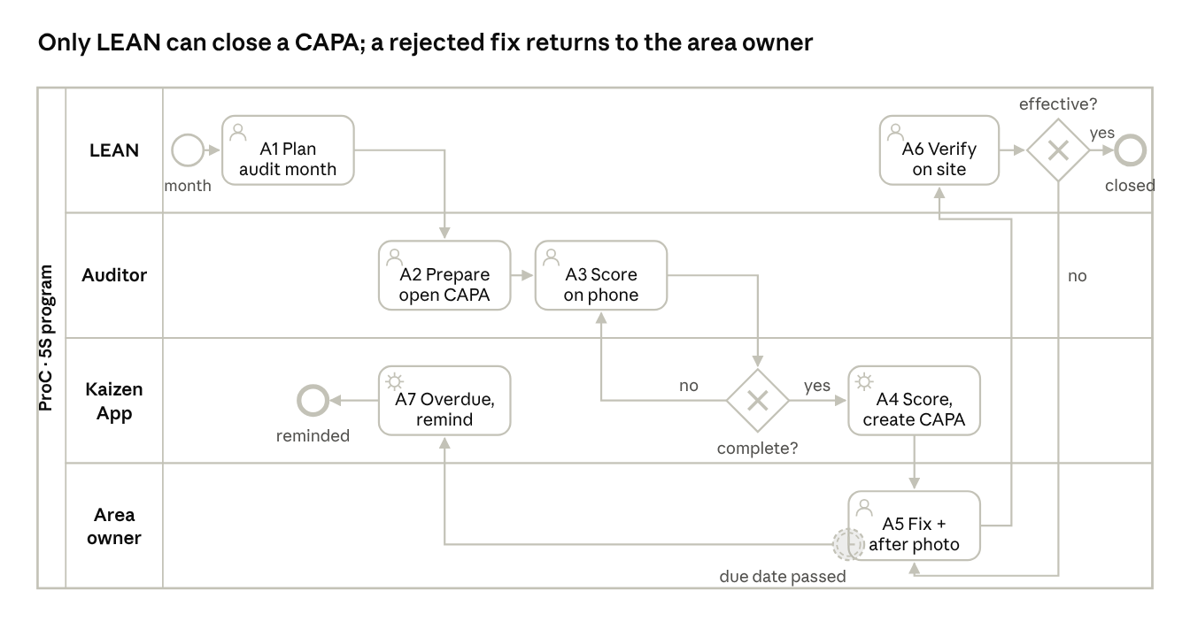
BPMN · 5S audit and CAPA · 4 lanes
Code | Lane | Element | Type | Data in Kaizen App
Start | LEAN | New month | None start event | —
A1 | LEAN | Plan audits for the month: area, lead auditor, type | User task | audit_plan
A2 | Auditor | Review last score, open CAPA, recent ideas of the area | User task | reads audit, capa, quick_idea
A3 | Auditor | Score 50 questions on the phone; finding, zone and photo for score ≤ 2; optional AI check | User task | audit, audit_answer, ai_scan
G1 | Kaizen App | Complete? (all applicable questions answered, evidence present) | Exclusive gateway | no → back to A3
A4 | Kaizen App | Compute %S, total, conclusion, maturity; create one CAPA per score ≤ 2; notify the area owner | Service task | audit (Submitted), capa, notification
A5 | Area owner | Write 5 Why and action, fix, upload after photo, report done | User task | capa
Timer | Area owner (on A5) | Due date passed while A5 is open | Non-interrupting boundary timer event | capa.due_date
A7 | Kaizen App | Mark CAPA Overdue, remind owner and department head | Service task | capa, notification; end "reminded"
A6 | LEAN | Verify the after photo on site or in the app | User task | capa.verified_by
G2 | LEAN | Effective? | Exclusive gateway | yes → end "closed"; no → returned to A5 with comment

7.2 Quick idea
The department head is the only approval step; an idea the employee already implemented, with an after photo, goes straight to the T1 reward line.
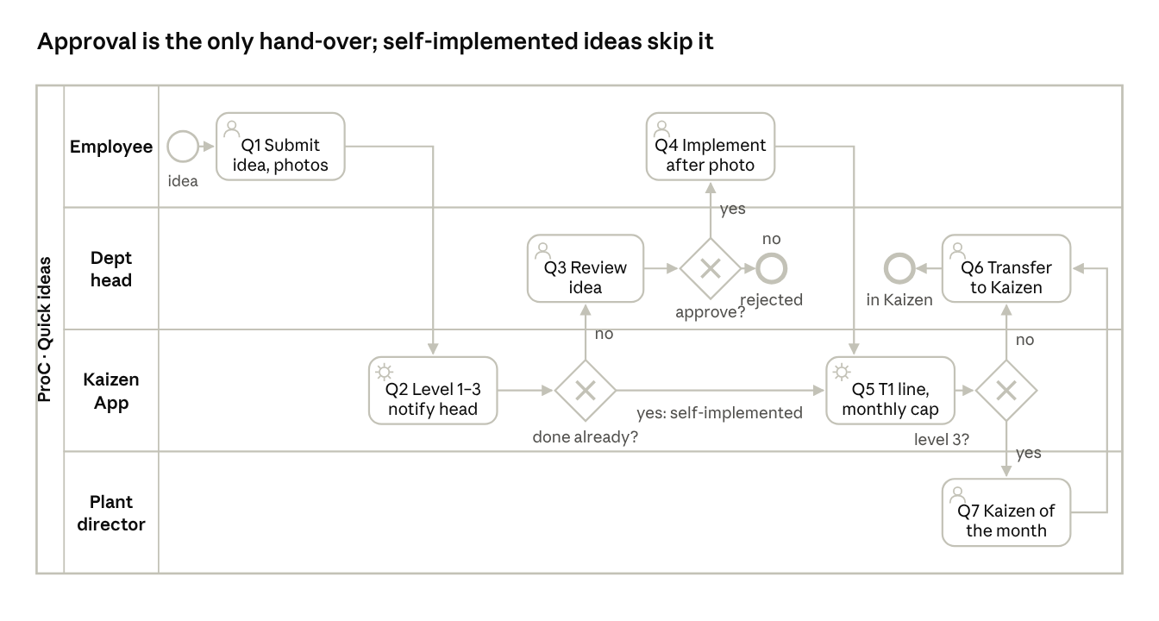
BPMN · quick idea · 4 lanes
Code | Lane | Element | Type | Data in Kaizen App
Start | Employee | Idea noticed | None start event | —
Q1 | Employee | Submit idea: area, S, problem, idea, photos, benefits; optional 5 Why, data, standard | User task | quick_idea, file
Q2 | Kaizen App | Compute level 1–3; notify the department head | Service task | quick_idea.level, notification
G1 | Kaizen App | Done already? (self-implemented with after photo) | Exclusive gateway | yes → Q5; no → Q3
Q3 | Department head | Review the idea, decide, comment (SLA 2 days) | User task | approval_step
G2 | Department head | Approve? | Exclusive gateway | yes → Q4; no → end "rejected"
Q4 | Employee (or department head) | Implement, upload after photo | User task | quick_idea status Implemented
Q5 | Kaizen App | Create T1 reward line for (author, month); cap 1,000,000 VND per person at month close | Service task | reward_line T1
G3 | Kaizen App | Level 3? | Exclusive gateway | yes → Q7; no → Q6
Q7 | Plant director (or LEAN) | Consider as Kaizen of the month; if chosen, T2 line | User task | reward_line T2
Q6 | Department head (or LEAN) | Transfer to Kaizen; system issues KZ-QI code | User task | quick_idea.kaizen_code; end "in Kaizen"
A department head can also upgrade an idea to a PDCA project at G2 instead of approving it; the flow then continues in 7.3.

7.3 Project approval, tollgates and acceptance
A project crosses up to four departments before any work is recorded, then returns to the team for each phase; money is released twice.
a. Project approval (the longest chain: R&D or investment ≥ 500 M VND)
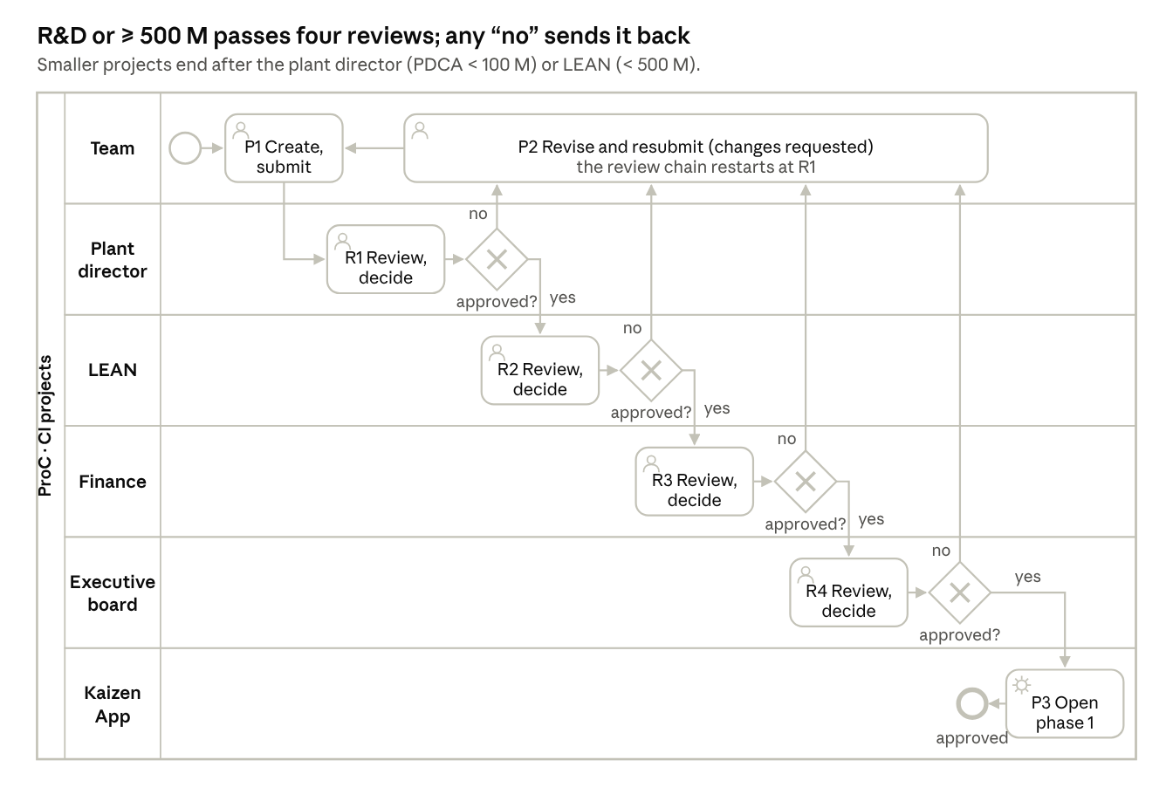
BPMN · project approval · 6 lanes
Code | Lane | Element | Type | Data in Kaizen App
P1 | Team | Fill the wizard and submit | User task | project, approval_flow (round 1)
R1 → G1 | Plant director | Review and decide (all projects) → approved? | User task + exclusive gateway | approval_step 1
R2 → G2 | LEAN | Review method and overlap (DMAIC, R&D, ≥ 100 M) → approved? | User task + exclusive gateway | approval_step 2
R3 → G3 | Finance | Review NPV and budget source (R&D, ≥ 500 M) → approved? | User task + exclusive gateway | approval_step 3
R4 → G4 | Executive board | Final review (R&D, ≥ 500 M) → approved? | User task + exclusive gateway | approval_step 4
P2 | Team | Revise and resubmit after any “no” with comment | User task | approval_flow round +1, steps reset
P3 | Kaizen App | Generate phases and checklists, open phase 1, notify the team | Service task | project_phase, phase_check, notification; end "approved"
The number of R/G pairs comes from approval_rule when the project is submitted; a step that does not apply is skipped, so a PDCA under 100 M VND goes from G1 straight to P3.
b. Tollgates, acceptance and sustainment
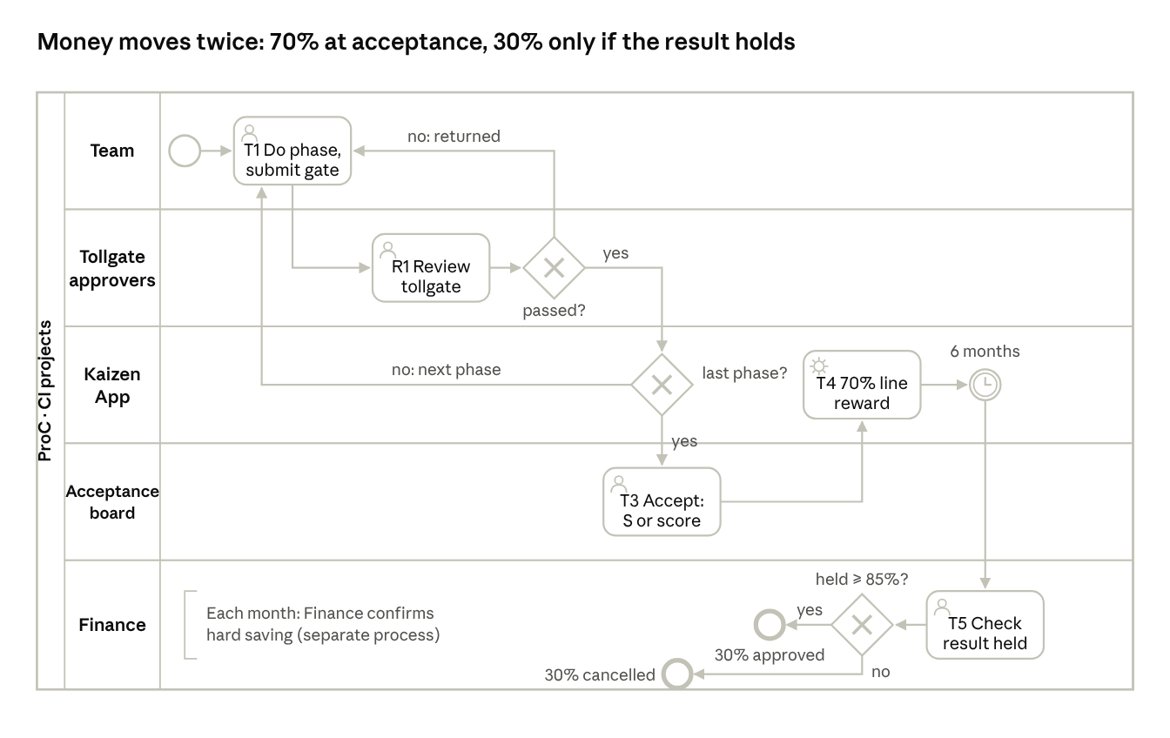
BPMN · tollgates, acceptance and sustainment · 5 lanes
Code | Lane | Element | Type | Data in Kaizen App
Start | Team | Phase opens | None start event | project_phase
T1 | Team | Do the phase work, tick checklist, enter monthly KPI, cost, hours; submit the tollgate | User task | phase_check, project_month, approval_flow (Tollgate)
R1 | Tollgate approvers | Review the tollgate (approvers per phase and method, PRD 3.7) | User task | approval_step
G1 | Tollgate approvers | Passed? | Exclusive gateway | no → back to T1 with comment
G2 | Kaizen App | Last phase? | Exclusive gateway | no → next phase opens (T1); yes → T3
T3 | Acceptance board (LEAN, EXEC) | Accept: Finance-confirmed S, or score 0–100 | User task | project.accepted_at, s_confirmed_vnd or acceptance_score
T4 | Kaizen App | Create T3 reward line for 70% | Service task | reward_line T3_ACCEPT
Timer | Kaizen App | Wait 6 months from acceptance | Timer intermediate catch event | scheduled job
T5 | Finance (or LEAN) | Check that ≥ 85% of the result is held | User task | project.sustained_at
G3 | Finance | Held ≥ 85%? | Exclusive gateway | yes → end "30% approved" (reward_line T3_SUSTAIN); no → end "30% cancelled" with reason
Note | Finance | Monthly confirmation of hard saving is its own process | Text annotation | project_month.saving_confirmed_by

7.4 Month close and reward payout
Nobody types a reward amount: a timer starts the month close, the system writes the reward lines, and three approvals (department head, LEAN, Finance) release them to payroll as a file.
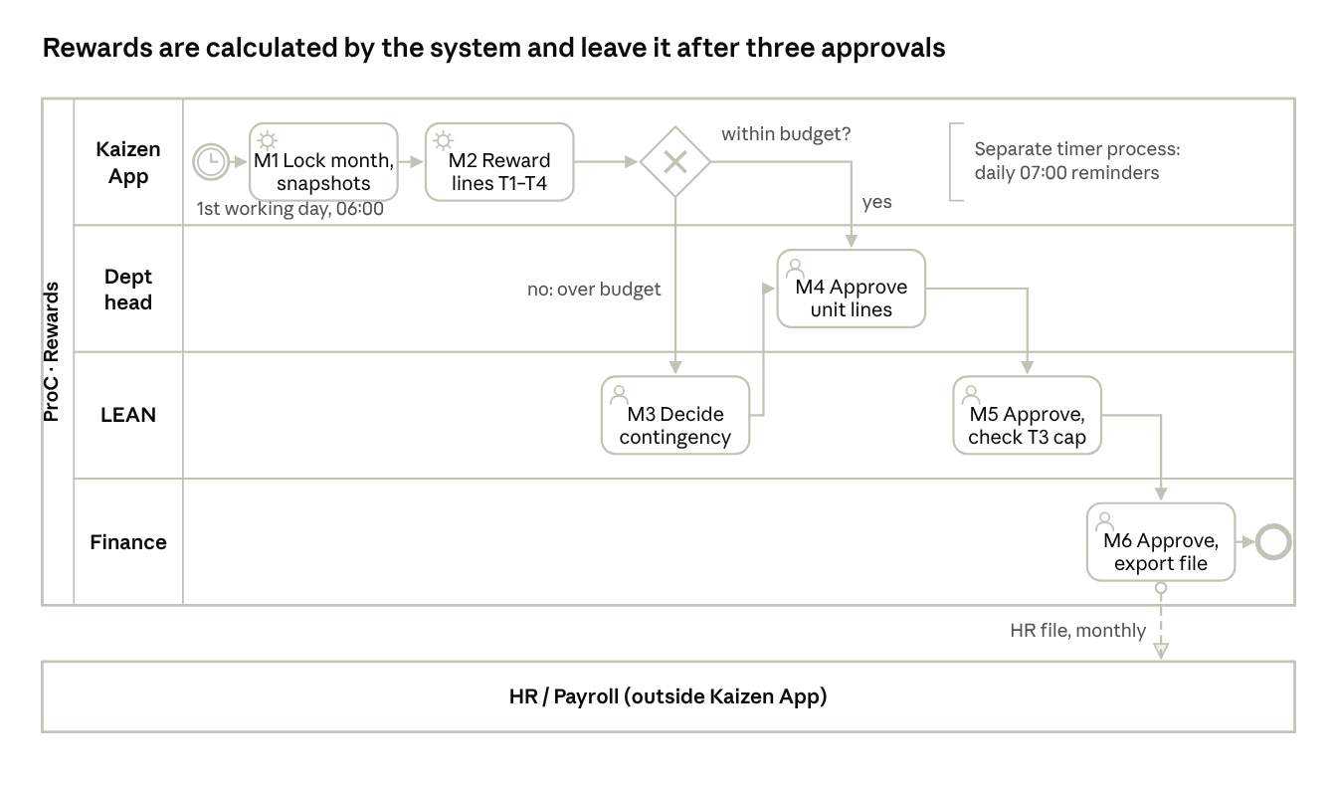
BPMN · month close and reward payout · 5 lanes
Code | Lane / pool | Element | Type | Data in Kaizen App
Start | Kaizen App | 1st working day of the month, 06:00 | Timer start event | scheduled job
M1 | Kaizen App | Lock Finance-confirmed project_month rows; write snapshots (savings, run-rate, EVM, quality) | Service task | project_month.locked, project_snapshot
M2 | Kaizen App | Create reward lines: T1 with the 1 M per person cap, T2, T3 from acceptances and sustainments; T4 at quarter close | Service task | reward_line (Pending)
G1 | Kaizen App | Within budget? (each budget line, and T3 ≤ 6% of confirmed saving) | Exclusive gateway | no → M3
M3 | LEAN | Decide: release the 20% contingency, or cut or defer lines with a reason | User task | reward_line status, comment
M4 | Department head | Approve T1 and T2 lines of their own unit | User task | reward_line Approved
M5 | LEAN | Approve all lines; check T3 cap and duplicates | User task | reward_line Approved
M6 | Finance | Final approval; export the HR file (person, employee no, line, amount, period) | User task | reward_line Exported, file; end event
Message | ProC → HR / Payroll pool | HR file, monthly | Message flow | file hash logged
Note | Kaizen App | Daily 07:00 reminders run as a separate timer-started process | Text annotation | notification
HR pays the amounts with the monthly salary in its own process, outside Kaizen App, so its pool is collapsed.
The same month-close job also refreshes report aggregates.

7.5 Email reports to leadership
Scheduled reports and events (audit submitted, high-severity finding) enter one send path; only the emails for the executive board wait for LEAN to review and add a commentary.
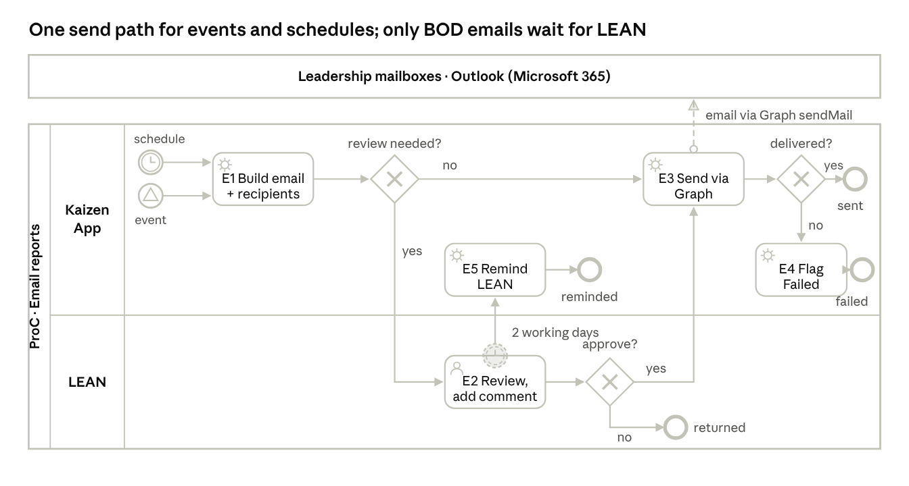
BPMN · email reports to leadership · 1 pool, 2 lanes, 1 external pool
Code | Lane / pool | Element | Type | Data in Kaizen App
Start | Kaizen App | Schedule of the subscription (Monday 07:30, 1st working day 08:00, quarter) | Timer start event | report_subscription
Start | Kaizen App | Audit submitted, NC major created, AI High detection confirmed | Signal start event | audit, capa, ai_detection
E1 | Kaizen App | Build the email from current data within the unit scope; resolve role recipients to mailboxes; store the HTML | Service task | email_message (Draft), email_recipient
G1 | Kaizen App | Review needed? (subscription requires_review) | Exclusive gateway | no → E3; yes → E2
E2 | LEAN | Review the email, write the commentary, decide | User task | email_message.note, status AwaitingReview
Timer | LEAN (on E2) | 2 working days without a decision | Non-interrupting boundary timer event | —
E5 | Kaizen App | Remind LEAN; never send automatically | Service task | notification; end "reminded"
G3 | LEAN | Approve? | Exclusive gateway | yes → E3; no → end "returned" (status Returned)
E3 | Kaizen App | Send through Microsoft Graph sendMail from the service mailbox; 3 retries at 1, 5 and 15 minutes | Service task | email_message Sent, email_recipient.graph_message_id
Message | Kaizen App → Leadership pool | Email delivered to Outlook | Message flow | —
G2 | Kaizen App | Delivered? | Exclusive gateway | yes → end "sent"; no → E4
E4 | Kaizen App | Flag Failed and notify LEAN in the app | Service task | email_message Failed, notification; end "failed"

